**Indian Institute of Management, Ahmedabad**

**Accelerated General Management Programme - 2020**

**Managerial Computing Exam**

**04th October 2020 Time: 2 hours**

**Instructions**

1. Open Book exam
2. Please fill both doc and spreadsheet
3. Submit both the files on Moodle.

**Question 1 (22 points)**

We are given the following monthly data concerning Ahmedabad’s weather in Range **A2: E14** (Refer to Excel Sheet-1). Answer the following questions concerning this data.

1. Write a formula for cell B16 to find the highest mean. **(2 points)**

**B16**: =MAX(D3:D14)

1. Write a formula for cell B17 to find the month with the highest mean. **(6 points)**

**B17**: =INDEX(A3:E14,MATCH(MAX(D3:D14),D3:D14,0),1)

1. Write a formula for cell B18 to obtain the low temperature for the month with the highest mean (the month in cell B17). **(4 points)**

**B18**: =INDEX(B3:E14,MATCH(B17,A3:A14,0),2)

1. Write a formula in B20, to calculate the average of mean greater than or equal to 28. You can use cells E19 and E20 for the criteria range. **(5 points)**

**E19**:Mean **E20**:>=28

**B20**: DAVERAGE(A2:E14,D2,E19:E20)

1. Months in which the high temperature exceeds 38 degrees Celsius, OR in which the low is less than 14 degrees Celsius have a high probability of school holidays. We use the advanced filter option to find all months which have a high probability of a holiday. These need to be listed in cells A22 onwards**.** You can use the range D22 to E24 for the criteria to be used for the advanced filter. Fill in the contents for the following cells to be used for the criteria:

**(5 points)**

**D22**: High **E22**: Low

**D23**: >38 **E23**:-

**D24**: **E24**:<14

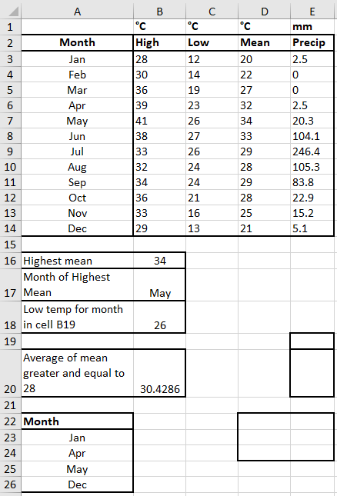

than or equal to

B17

**Question 2** (Refer to Excel Sheet-2)**: (8 points)**

UGC generates subject IDs for two top institutes as 8 characters, where the first 4 characters are the year in which a particular department was formed, then the next two are the institute initial code, and the last 3 are the branch code.

**Example** : 1994C3365 = 1994 & SN & EC

It wants to change the branch code to a more meaningful new system as given in Table 1, for example, EC will change to EC101 and the new id will be 1994SNEC101.

This is done in 3 steps as shown in the spreadsheet.

**Step 1**: The old branch code is extracted. Write a formula in cell B2 which will be copied downwards, to do this.

**Formula in B2**:

=

**Step 2**: In C2, find the new branch code corresponding to the old branch code in B2.

Again, this formula will be copied downwards.

**Formula in C2**:

=

**Step 3**: Generate the new Id in cell D2

**Formula in D2**:

=

